# Assignment Report: Installing and Testing a Local LLM

## Objective

The objective of this task was to install a local Large Language Model (LLM), test its functionality with a simple prompt, measure response time, and document troubleshooting steps.

## Installation Steps

1. Downloaded and installed Ollama from the official site (https://ollama.ai/download).  
2. Verified installation in Command Prompt with: **ollama –version**

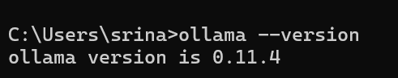

3. Pulled the LLaMA 3.2 model locally using: **ollama pull llama3.2**

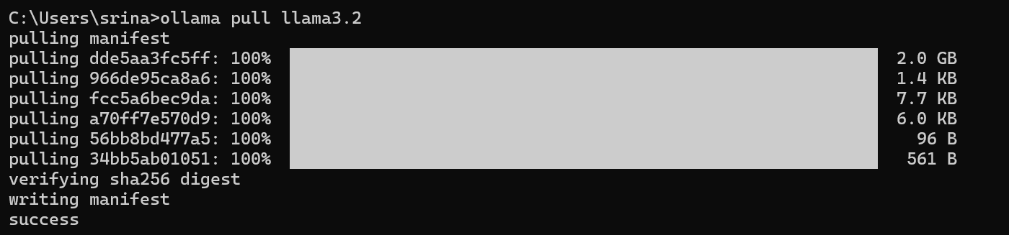

### Sample Prompt and Output

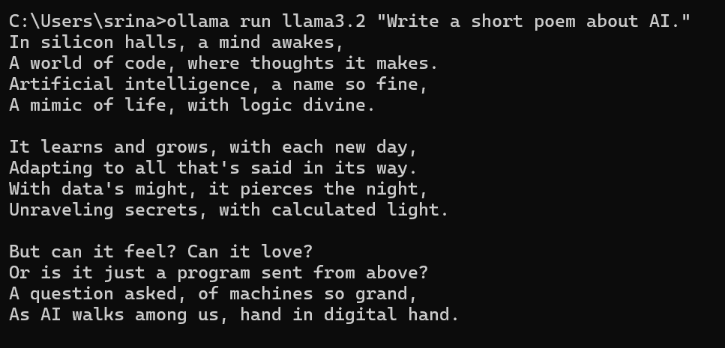

### Response Time Measurement

Measured using PowerShell:

**Measure-Command { ollama run llama3.2 "Write a short poem about AI." }**

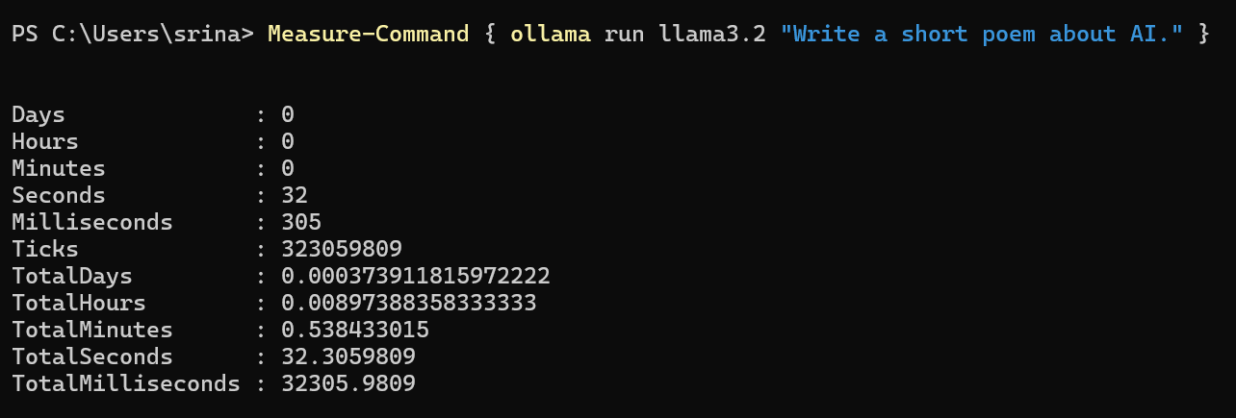  
  
Result: ~32.3 seconds

## Troubleshooting Notes

- Initially tried to measure time in CMD using 'time', but it attempted to change the system clock instead of measuring runtime.  
- Switched to PowerShell and used 'Measure-Command', which successfully gave response time.  
- Output is not displayed when wrapped in 'Measure-Command', so I used the CMD output for the poem and PowerShell for timing.

## Reflection on Performance & Installation

- Installation experience: Straightforward; Ollama made it easy to pull and run a state-of-the-art LLM locally.  
- Performance: The model responded correctly to the test prompt and produced a meaningful poem. However, response time (~32 seconds) was slower than expected, likely due to model size and system hardware.  
- Overall: Successful experiment — I was able to install, run, and measure a local LLM, and also learned how to troubleshoot PowerShell vs CMD differences.